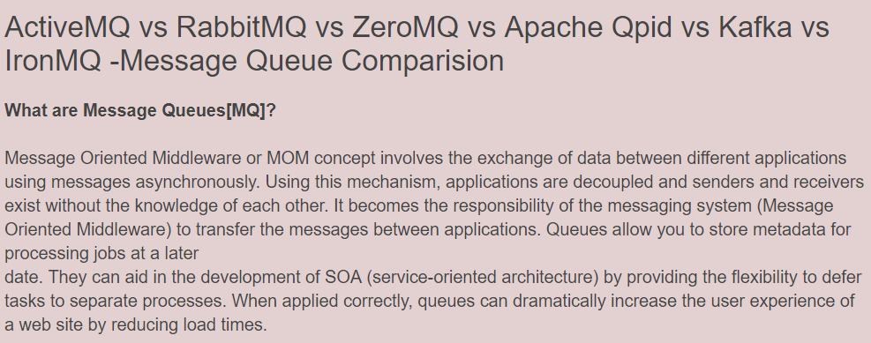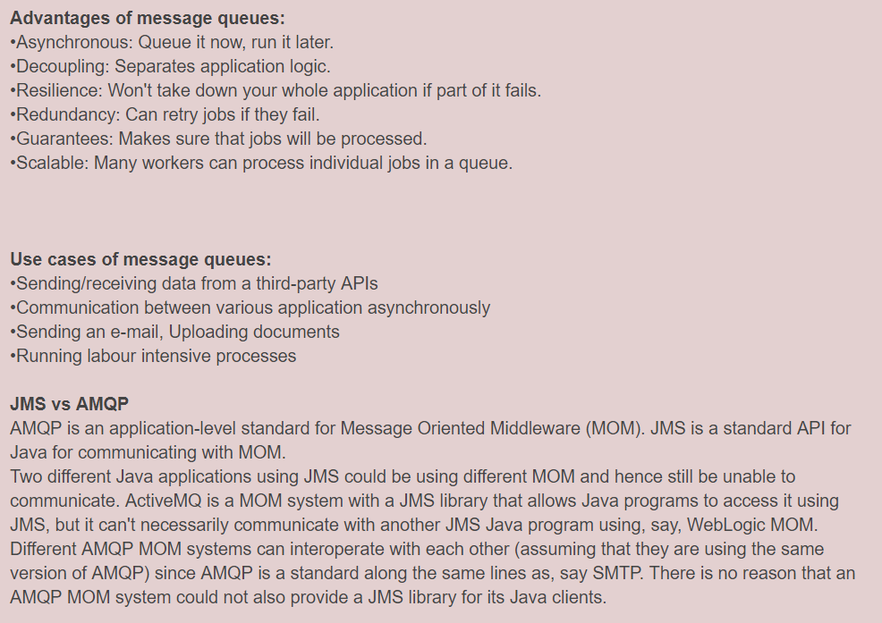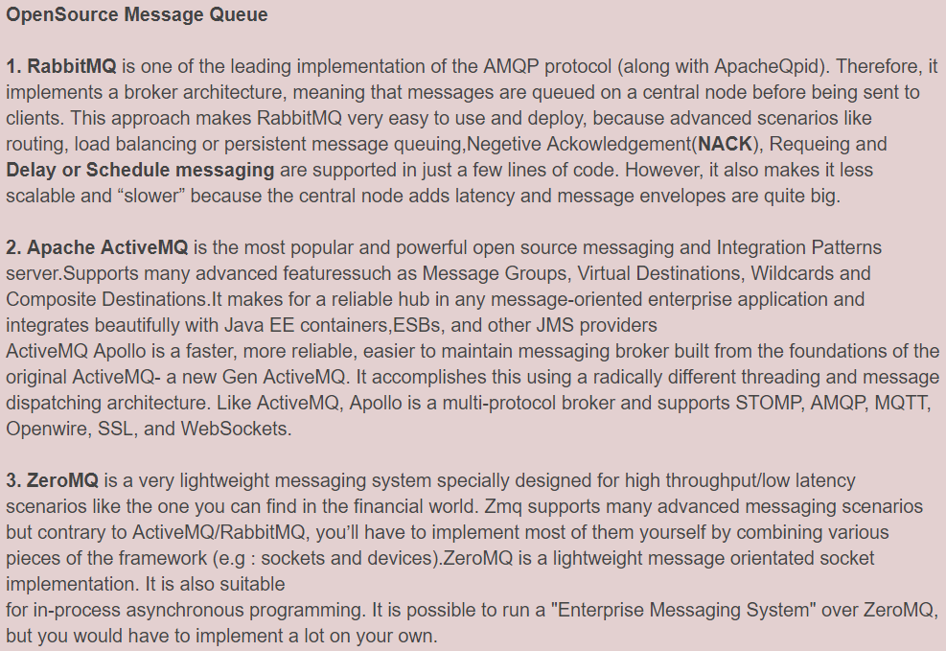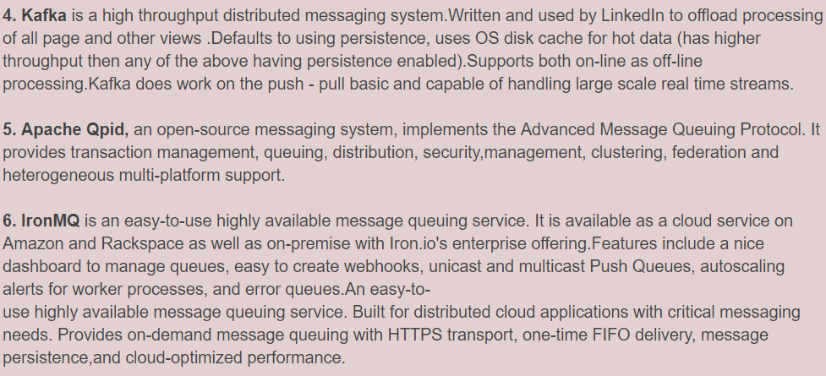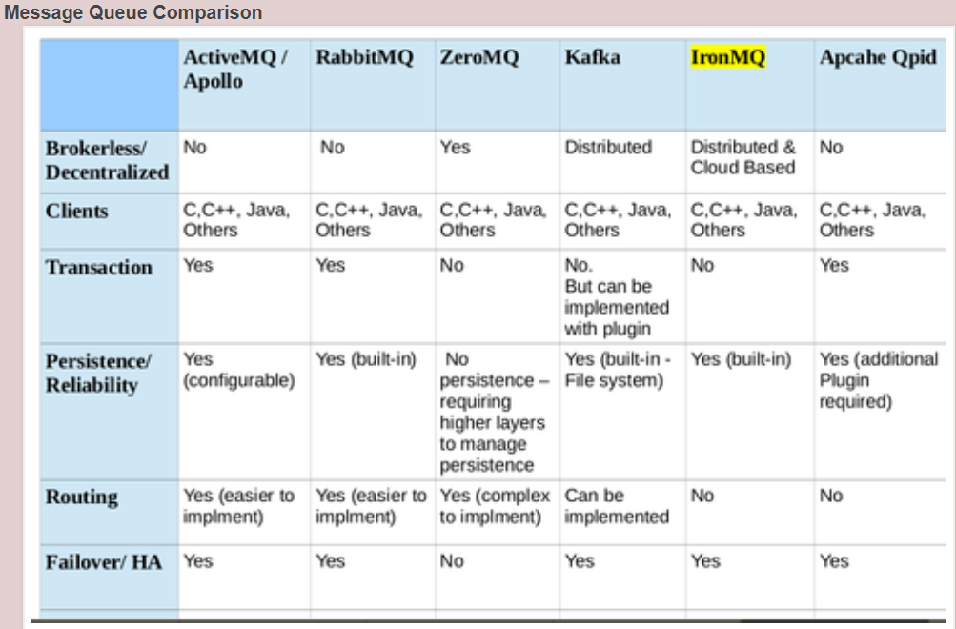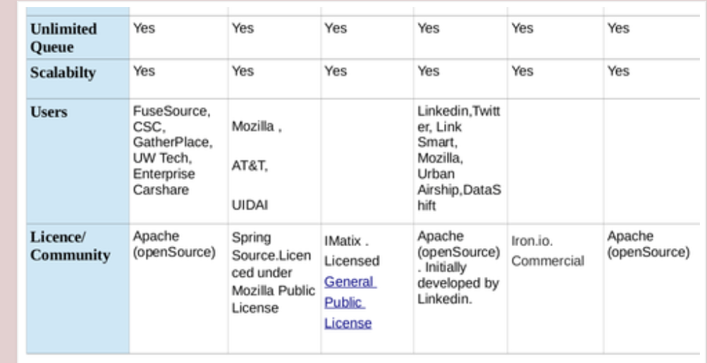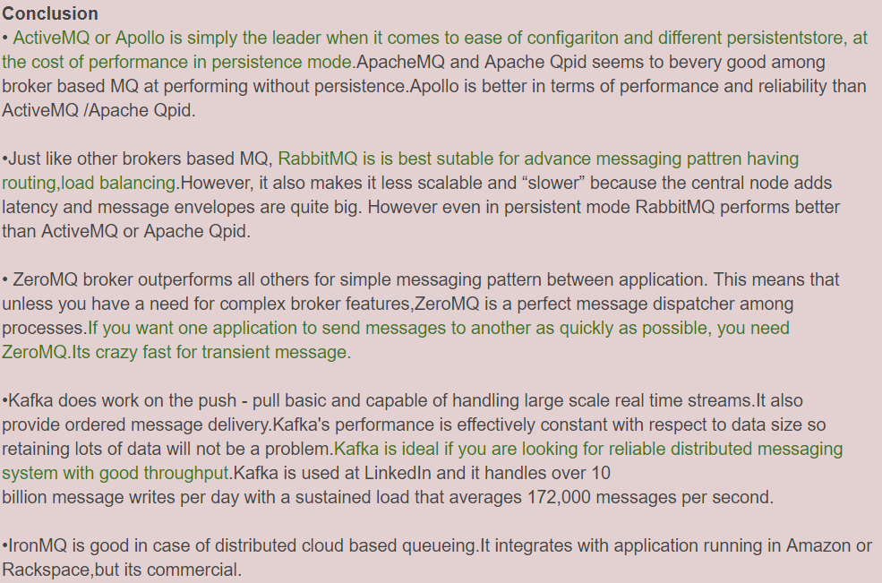

http://kuntalganguly.blogspot.in/2014/08/message-queue-comparision.html
*************************************************************************************

What is the difference between a message queue and a task queue? Why would a task queue require a message broker like RabbitMQ, Redis, Celery, or IronMQ to function?

The primary difference is in its high level purpose.
Message Queue are the basic functionality of passing, holding, and delivering messages across an application or service oriented system.
Tasks Queue manage work to be done and is considered a type of message queue
The popular queues differ in functionality such as push/pull queues, subscribers, unicast(round robin), multicast(all subscribers at once), FIFO, single message delivery error handling and counts and analytics, gui, command line tools.
Use the best tool for the job.
Redis, message queue open sourced, is great for a simple message broker but messages can be lost.
RabbitMQ, self-hosted message queue open sourced, use a different protocol 'AMQP', is very popular but requires you to adapt the protocol and manage your own nodes. CloudAMQP is the only hosted rabbit solution I know of.
Amazon SQS, hosted message queue expected message latency is pretty high and has the possibility of messages being delivered twice. It is quite stable but lacks feature development from Amazon's end in my opinion.
IronMQ, a hosted message queue is pretty great for its single message delivery, fifo, and use the HTTP protocol over AMQP and is elastically scalable, private clusters, error/alert queues, gui, yadda yadda awesome!
Celery, self-hosted task queue open sourced, task queue, has support for scheduling, host your own node. primarily python support
Resque, task queue opens sourced, built on the above mentioned redis, requires you host your own nodes and manage their scaling, ruby based, works well with sidekiq.
IronWorker, hosted task queue AND the processing - gives you the complexity of being a task queue AND your task processing layer in one package. supports scheduling, supports all languages, and is elastically scalable, yadda yadda awesome!
Delayed_job, task queue open sourced, uses local database as the queue, not very flexible or efficient but can get the job done. ruby based
------------------------------------------------------------------------------------------------------------
Task Queue and Message Queue. RabbitMQ is a "MQ". It receives messages and delivers messages.
Celery is a Task Queue. It receives tasks with their related data, runs them and delivers the results.
Let's forget Celery for a moment. Let's talk about RabbitMQ. What would we usually do? Our Django/Flask app would send a message to a queue. We will have some workers running which will be waiting for new messages in certain queues. When a new message arrives, it starts working and processes the tasks.
Celery manages this entire process beautifully. We no longer need to learn or worry about the details of AMQP or RabbitMQ. We can use Redis or even a database (MySQL for example) as a message broker. Celery allows us to define "Tasks" with our worker codes. When we need to do something in the background (or even foreground), we can just call this task (for instant execution) or schedule this task for delayed processing. Celery would handle the message passing and running the tasks. It would launch workers which would know how to run your defined tasks and store the results. So, you can later query the task result or even task progress when needed.
My understanding is that celery is just a very high level of abstraction to implement the producer / consumer of events. It takes out several painful things you need to do to work for example with rabbitmq. Celery itself is not the queue. The events queues are stored in the system of your choice, celery helps you to work with such events without having to write the producer / consumer from scratch.
Celery is a queue Wrapper/Framework which takes away the complexity of having to manage the underlying AMQP mechanisms/architecture that come with operating RabbitMQ directly
------------------------------------------------------------------------------------------------------------
To put it simply: Task or message, they can be thought of or used interchangeably. It's the asynchronous operation that matters. (repeat that last line to yourself :)) The point of having a queue is that one guy can ask to do something or say something and forget about it, and another guy can follow up on it.
A task/message queue: Think of this like a passive data structure which acts like a queue, it 'stores' tasks and keeps them for processing later on. True, there is a process who manages this queue, but it doesn't do more, it just stores things and gives them when asked in an orderly way.
Righto, great. But who processes it? The worker threads.
Okay. So now, we have got 3 things.
A task/message.
A process who adds the tasks in to the task queue (data structure), and maintains this task queue.
Worker processes who take the tasks/messages from this queue and execute them.
So, you mean workers can read this queue and remove tasks from them? Yes they can, but this leads to problems (er.. race conditions and such).
Enter the 'message broker'.
The 'message broker' is the one who takes the tasks from the task queue and distributes them to worker processes (even if they are on different machines) and manages the integrity of task completion, retrying tasks if workers fail, giving faster workers more tasks, and some other housekeeping for distributed processing.
Aha! So that's what the message broker does! Wait, why can't the 'Task/Message queue' manage the giving away of tasks to these workers, instead of just managing the queue?
They can and do so, this is why there is confusion sometimes. Redis, primarily, a high performance passive data store, also does message broking/scheduling
Some message brokers (like rabbitMQ) use their own task queues to store and schedule them.
The roles/functions may overlap, but the concept is essentially the same.

https://www.quora.com/What-is-the-difference-between-a-message-queue-and-a-task-queue-Why-would-a-task-queue-require-a-message-broker-like-RabbitMQ-Redis-Celery-or-IronMQ-to-function
*************************************************************************************

Understanding When to use RabbitMQ or Apache Kafka
RabbitMQ is a “traditional” message broker that implements variety of messaging protocols. It was one of the first open source message brokers to achieve a reasonable level of features, client libraries, dev tools, and quality documentation. RabbitMQ was originally developed to implement AMQP, an open wire protocol for messaging with powerful routing features. While Java has messaging standards like JMS, it’s not helpful for non-Java applications that need distributed messaging which is severely limiting to any integration scenario, microservice or monolithic. With the advent of AMQP, cross-language flexibility became real for open source message brokers.
Apache Kafka is developed in Scala and started out at LinkedIn as a way to connect different internal systems. At the time, LinkedIn was moving to a more distributed architecture and needed to reimagine capabilities like data integration and real-time stream processing, breaking away from previously monolithic approaches to these problems. Kafka is well adopted today within the Apache Software Foundation ecosystem of products and is particularly useful in event-driven architecture.
Architecture and Design
RabbitMQ is designed as a general-purpose message broker, employing several variations of point to point, request/reply and pub-sub communication styles patterns. It uses a smart broker / dumb consumer model, focused on consistent delivery of messages to consumers that consume at a roughly similar pace as the broker keeps track of consumer state. It is mature, performs well when configured correctly, is well supported (client libraries Java, .NET, node.js, Ruby, PHP and many more languages) and has dozens of plugins available that extend it to more use cases and integration scenarios.
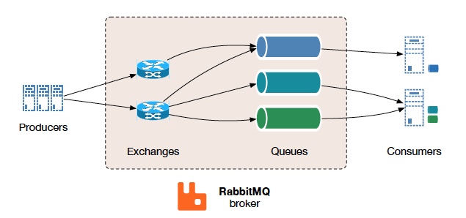
Figure 15 - Simplified overall RabbitMQ architecture. Source: http://kth.diva-portal.org/smash/get/diva2:813137/FULLTEXT01.pdf
Communication in RabbitMQ can be either synchronous or asynchronous as needed. Publishers send messages to exchanges, and consumers retrieve messages from queues. Decoupling producers from queues via exchanges ensures that producers aren't burdened with hardcoded routing decisions. RabbitMQ also offers a number of distributed deployment scenarios (and does require all nodes be able to resolve hostnames). It can be setup for multi-node clusters to cluster federation and does not have dependencies on external services (but some cluster formation plugins can use AWS APIs, DNS, Consul, etcd).
Apache Kafka is designed for high volume publish-subscribe messages and streams, meant to be durable, fast, and scalable. At its essence, Kafka provides a durable message store, similar to a log, run in a server cluster, that stores streams of records in categories called topics.
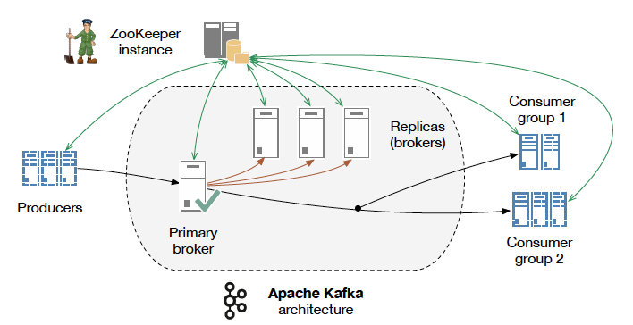
Figure 11 - Global Apache Kafka architecture (with 1 topic, 1 partition, replication factor 4). Source: http://kth.diva-portal.org/smash/get/diva2:813137/FULLTEXT01.pdf
Every message consists of a key, a value, and a timestamp. Nearly the opposite of RabbitMQ, Kafka employs a dumb broker and uses smart consumers to read its buffer. Kafka does not attempt to track which messages were read by each consumer and only retain unread messages; rather, Kafka retains all messages for a set amount of time, and consumers are responsible to track their location in each log (consumer state). Consequently, with the right developer talent creating the consumer code, Kafka can support a large number of consumers and retain large amounts of data with very little overhead. As the diagram above shows, Kafka does require external services to run - in this case Apache Zookeeper, which is often regarded as non-trivial to understand, setup and operate.

Requirements and Use Cases
Many developers begin exploring messaging when they realize they have to connect lots of things together, and other integration patterns such as shared databases are not feasible or too dangerous.
Apache Kafka includes the broker itself, which is actually the best known and the most popular part of it and has been designed and prominently marketed towards stream processing scenarios. In addition to that, Apache Kafka has recently added Kafka Streams which positions itself as an alternative to streaming platforms such as Apache Spark, Apache Flink, Apache Beam/Google Cloud Data Flow. The documentation does a good job of discussing popular use cases like Website Activity Tracking, Metrics, Log Aggregation, Stream Processing, Event Sourcing and Commit logs. One of those use cases it describes is messaging, which can generate some confusion. So, let’s unpack that a bit and get some clarity on which messaging scenarios are best for Kafka for, like:
- Stream from A to B without complex routing, with maximal throughput (100k/sec+), delivered in partitioned order at least once.
- When your application needs access to stream history, delivered in partitioned order at least once. Kafka is a durable message store and clients can get a “replay” of the event stream on demand, as opposed to more traditional message brokers where once a message has been delivered, it is removed from the queue.
- Kafka's durable storage, one it's Stream Processing
- Event Sourcing
RabbitMQ is a general-purpose messaging solution, often used to allow web servers to respond to requests quickly instead of being forced to perform resource-heavy procedures while the user waits for the result. It’s also good for distributing a message to multiple recipients for consumption or for balancing loads between workers under high load (20k+/sec). When your requirements extend beyond throughput, RabbitMQ has a lot to offer: features for reliable delivery, routing, federation, HA, security, management tools and other features. Let’s examine some scenarios best for RabbitMQ, like:
- Your application needs to work with any combination of existing protocols like AMQP 0-9-1, STOMP, MQTT, AMQP 1.0.
- You need a finer-grained consistency control/guarantees on a per-message basis (dead letter queues, etc.) However, Kafka has recently added better support for transactions.
- Your application needs variety in point to point, request / reply, and publish/subscribe messaging
- Complex routing to consumers, integrate multiple services/apps with non-trivial routing logic
RabbitMQ can also effectively address several of Kafka’s strong uses cases above, but with the help of additional software. RabbitMQ is often used with Apache Cassandra when application needs access to stream history, or with the LevelDB plugin for applications that need an “infinite” queue, but neither feature ships with RabbitMQ itself.
For a deeper dive on microservice - specific use cases with Kafka and RabbitMQ, head over to the Pivotal blog and read this short post by Fred Melo.

Developer Experience
RabbitMQ officially supports Java, Spring, .NET, PHP, Python, Ruby, JavaScript, Go, Elixir, Objective-C, Swift - with many other clients and devtools via community plugins. The RabbitMQ client libraries are mature and well documented.
Apache Kafka has made strides in this area, and while it only ships a Java client, there is a growing catalog of community open source clients, ecosystem projects, and well as an adapter SDK allowing you to build your own system integration. Much of the configuration is done via. properties files or programmatically.
The popularity of these two options has a strong influence on many other software providers who make sure that RabbitMQ and Kafka work well with or on their technology.
Developer experience...it's not right to brush over the support that we provide in Spring Kafka, Spring Cloud Stream, etc.

Security and Operations
Both are strengths of RabbitMQ. RabbitMQ management plugin provides an HTTP API, a browser-based UI for management and monitoring, plus CLI tools for operators. External tools like CollectD, Datadog, or New Relic are required for longer term monitoring data storage. RabbitMQ also provides API and tools for monitoring, audit and application troubleshooting. Besides support for TLS, RabbitMQ ships with RBAC backed by a built-in data store, LDAP or external HTTPS-based providers and supports authentication using x509 certificate instead of username/password pairs. Additional authentication methods can be fairly straightforwardly developed with plugins.
These domains pose a challenge for Apache Kafka. On the security front, the recent Kafka 0.9 release added TLS, JAAS role based access control and kerberos/plain/scram auth, using a CLI to manage security policy. This made a substantial improvement on earlier versions where you could only lock down access at the network level, which didn’t work well for sharing or multi-tenancy.
Kafka uses a management CLI comprised of shell scripts, property files and specifically formatted JSON files. Kafka Brokers, Producers and Consumers emit metrics via Yammer/JMX but do not maintain any history, which pragmatically means using a 3rd party monitoring system. Using these tools, operations is able manage partitions and topics, check consumer offset position, and use the HA and FT capabilities that Apache Zookeeper provides for Kafka. While many view the requirement for Zookeeper with a high degree of skepticism, it does confer clustering benefits for Kafka users.
For example, a 3-node Kafka cluster the system is functional even after 2 failures. However, if you want to support as many failures in Zookeeper you need an additional 5 Zookeeper nodes as Zookeeper is a quorum based system and can only tolerate N/2+1 failures. These obviously should not be co-located with the Kafka nodes - so to stand up a 3 node Kafka system you need ~ 8 servers. Operators must take the properties of the ZK cluster into account when reasoning about the availability of any Kafka system, both in terms of resource consumption and design.

Performance
Kafka shines here by design: 100k/sec performance is often a key driver for people choosing Apache Kafka.
Of course, message per second rates are tricky to state and quantify since they depend on so much including your environment and hardware, the nature of your workload, which delivery guarantees are used (e.g. persistent is costly, mirroring even more so), etc.
20K messages per second is easy to push through a single Rabbit queue, indeed rather more than that isn't hard, with not much demanded in the way of guarantees. The queue is backed by a single Erlang lightweight thread that gets cooperatively scheduled on a pool of native OS threads - so it becomes a natural choke point or bottleneck as a single queue is never going to do more work than it can get CPU cycles to work in.
Increasing the messages per second often comes down to properly exploiting the parallelism available in one's environment by doing such things as breaking traffic across multiple queues via clever routing (so that different queues can be running concurrently). When RabbitMQ achieved 1 million message per second case basically came down entirely to doing that judiciously - but was achieved using lot of resources, around 30 RabbitMQ nodes. Most RabbitMQ users enjoy excellent performance with clusters made up of anywhere from three to seven RabbitMQ nodes.

Making the call
Absorb some research on a few of the other top options on the market. If you want to go deeper with the most popular options, a master’s thesis from Nicolas Nannoni inspired this article and it features a side by side comparison table in section 4.4 (page 39) that is still reasonably accurate two years later -- worth the read.
While researching, loop back with the stakeholders and the business as often as possible. Understanding the business use case is the single largest factor in making the right choice for your situation. Then, if you are pop psychology fan, your best bet is sleep on it, let it percolate, and let your instincts take over. You got this.
https://content.pivotal.io/blog/understanding-when-to-use-rabbitmq-or-apache-kafka

